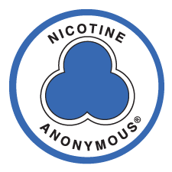
NICOTINE ANONYMOUS® MEETING
A 12-Step* Recovery Program of Mutual Support
for those who want to
stop smoking or live free of nicotine in any form

No dues or fees
*
Ongoing, join at anytime
*
You only need to bring a desire
to stop using nicotine
*
(Days - Time )
(Location)

Contact # _______________

*Twelve Steps and Twelve Traditions adapted with permission from Alcoholics Anonymous World Services, Inc.
(option: bottom area to be made into tear off strips with phone contact #)

